***Candidate Name: Varun Gupta***

***Email:*** [***Guptavarun294@gmail.com***](mailto:Guptavarun294@gmail.com)

***Steps Taken by me to perform the given tasks are:***

1. ***Connect the given csv file to Power BI by clicking on the “Get data” button.***

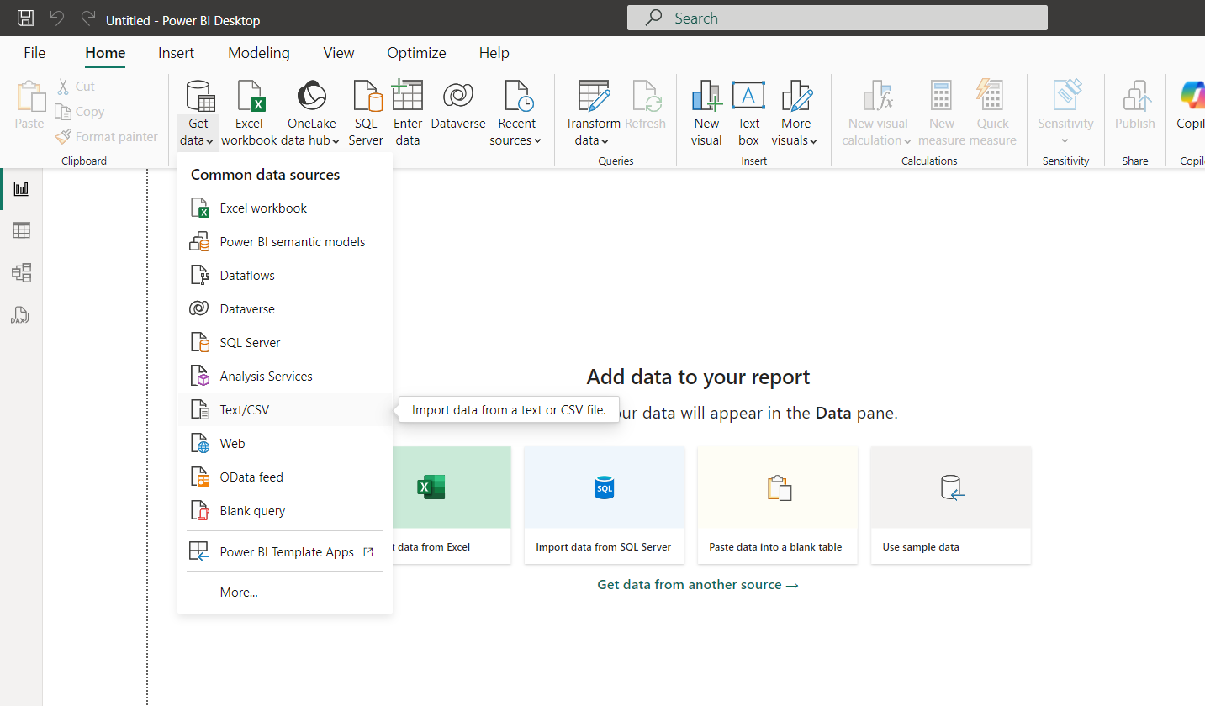

1. ***Then under home section click on Transform data, a new window will open where you have to right click on the csv file and then click duplicate.***

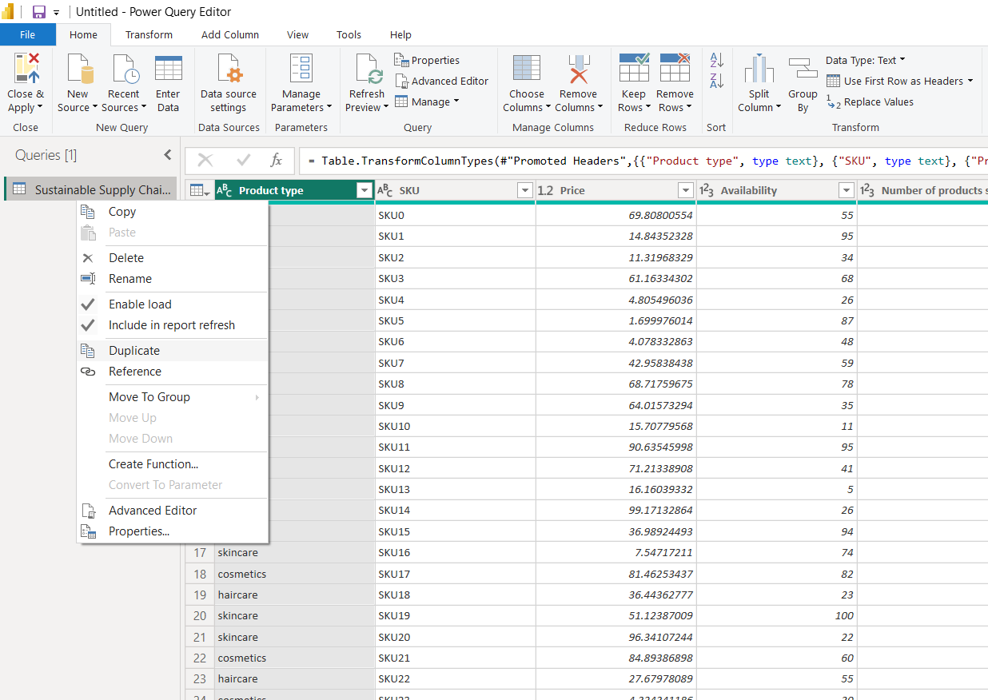

1. ***Then rename the duplicated table to “Inventory” and remove the undesired columns by right clicking on them and then clicking on remove option to get the desired table.***

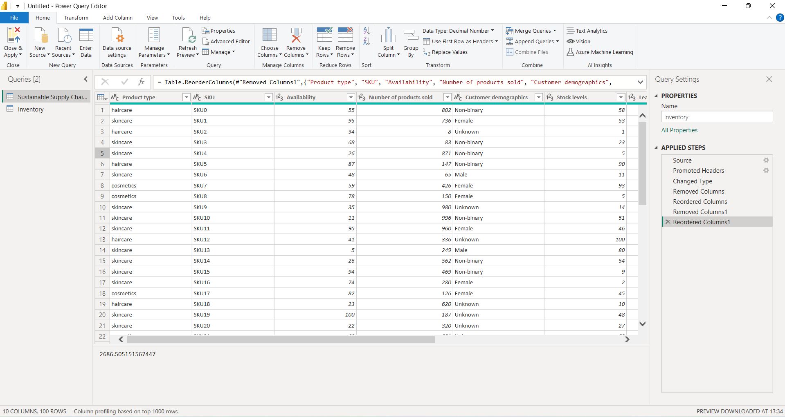

1. ***After this again create a duplicate of “Sustainable Supply Chain Performance” table and rename the duplicate to “Manufacturing” and then remove the undesired columns to get the desired table.***

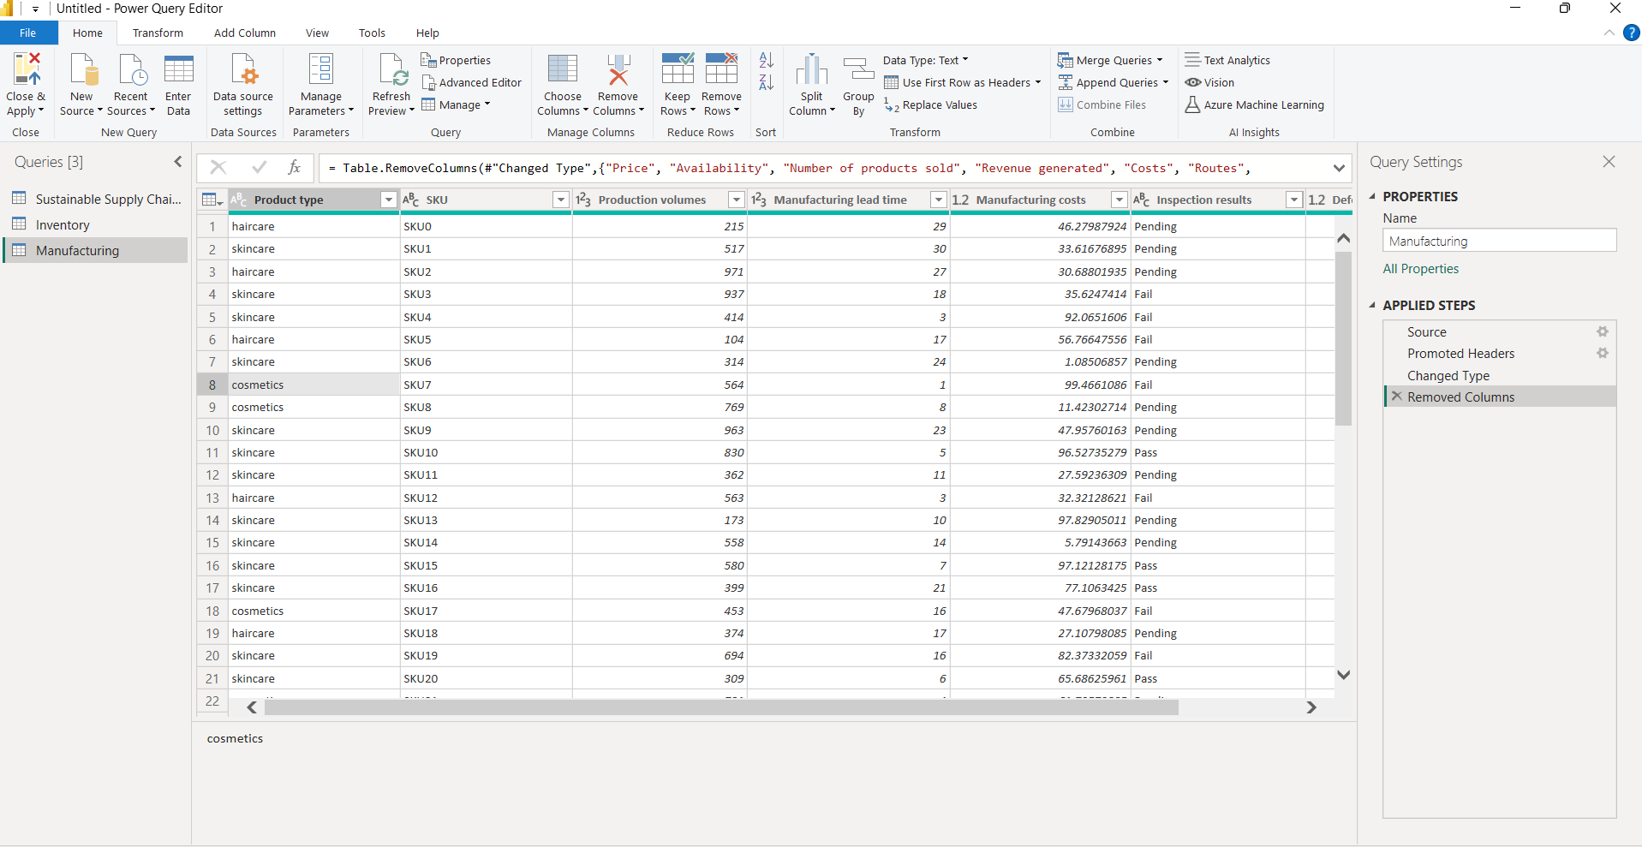

1. ***Now again create another duplicate of “Sustainable Supply Chain Performance” table and rename the duplicate to “Supplier” and then remove the undesired columns to get the desired table.***

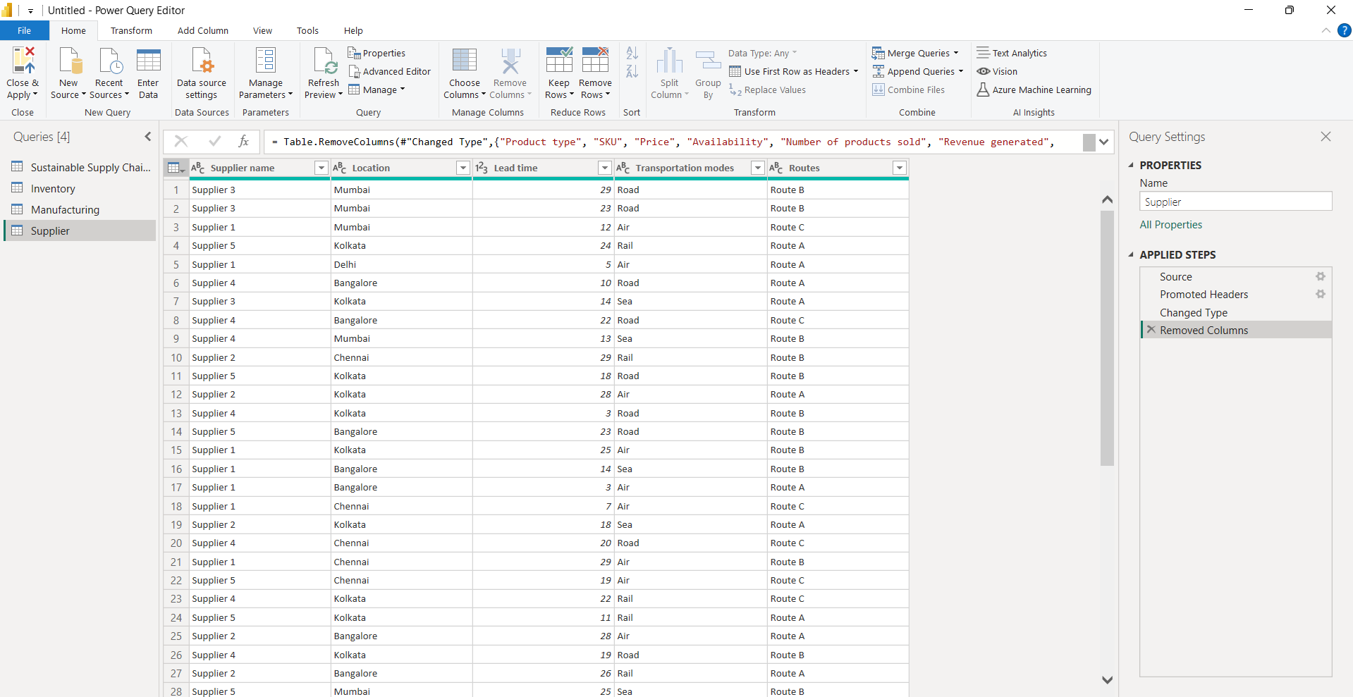

1. ***Now again create another duplicate of “Sustainable Supply Chain Performance” table and rename the duplicate to “Supply Chain” and then remove the undesired columns to get the desired table.***

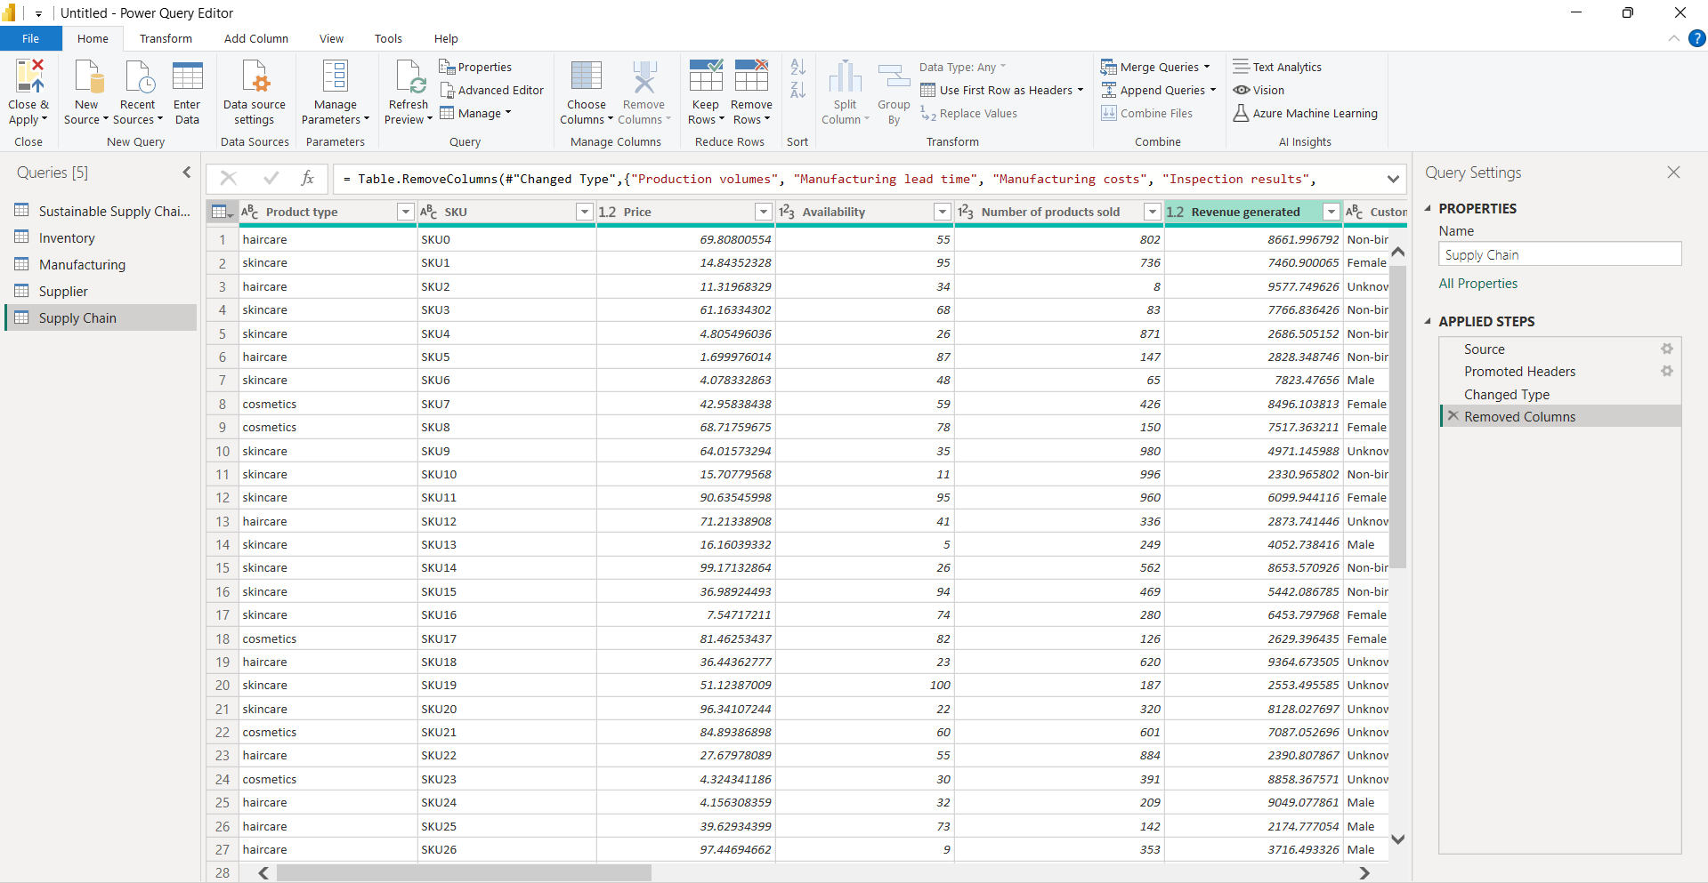

1. ***After creating all the desired tables, go to home section and click on “Close & Apply” so save your progress that you have done till now.***

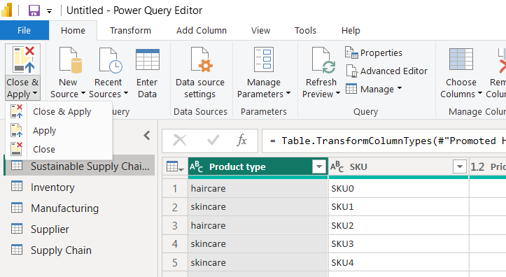

1. ***After this the following window will be shown.***

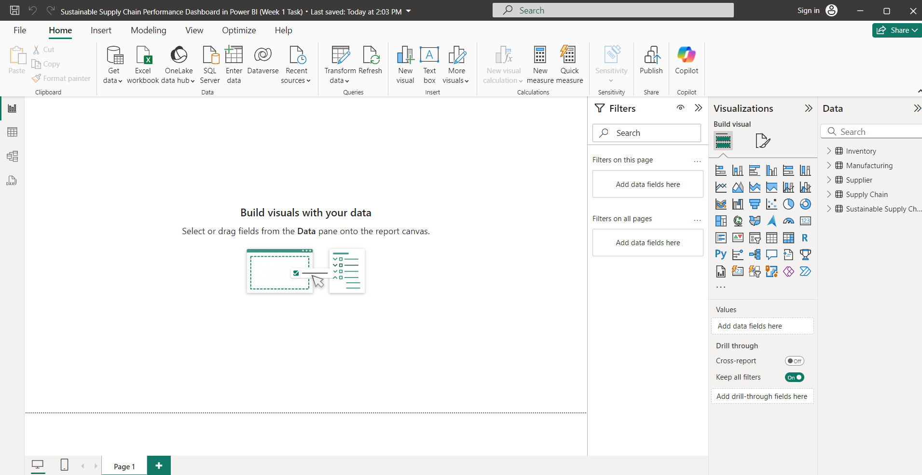

***This Sums up the work done by me in the week 1.***